# CGRA 352 – Assignment 2

300446258

Jackson Tume

*-Brief introduction of your functions in your programs.*

PatchMatch starts by initialising nnf with random values, then Propagation going left and up, then going right then down. After propagation it performs random search. It then repeats propagation and random search 5 times.

Image Quilting starts by randomly choosing a 100x100 pixel patch. It then tries a bunch of patches of the same size and compares the ssd between the overlapping regions of both patches. The minimum ssd is chosen as the next patch. Then the cost of the overlapping regions between the patches is computed, and the minimum cumulative cost is computed. The lowest column is found, using the lowest column an array is chosen by the cumulative cost, which we already know. Then using the overlaps and seam, we can merge the overlaps together into a new image. This is now repeated until the new image is 500px wide.

*-How to run your program to perform the functions required by the assignment.*

In the command line, type in the name of the function to run it,

E.G: typing “core” will run the Patch Match implementation, while typing “comp” will run the Image Quilting

*-The results of Core and Completion*

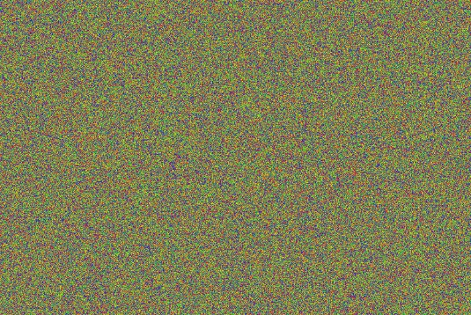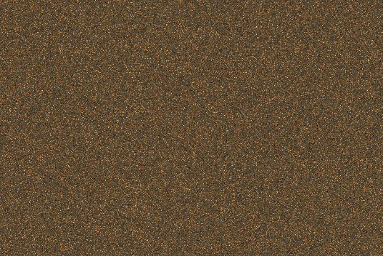

Results of Core Initialisation

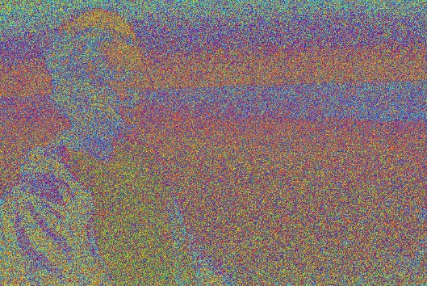

Results of Core Random Search

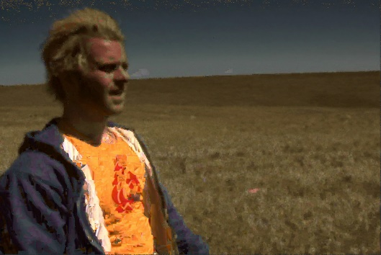

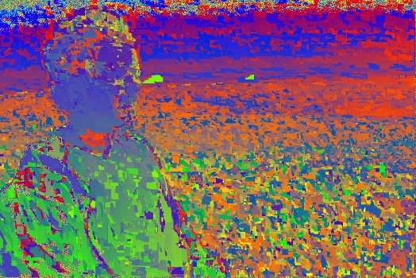

Results of Core Propagation

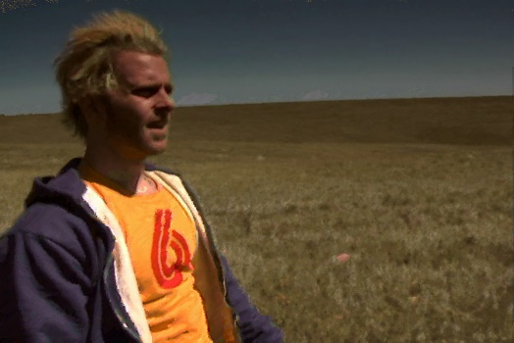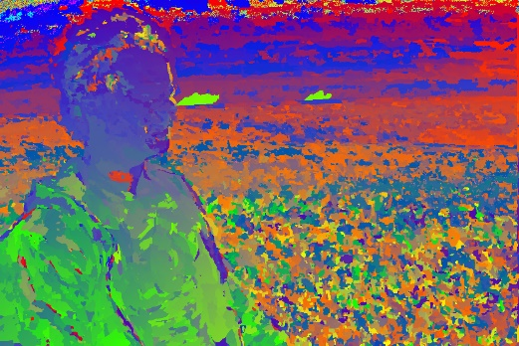

Results of Core Iteration

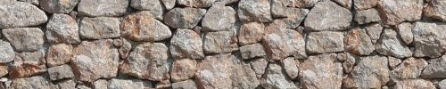

Results of Image Quilting

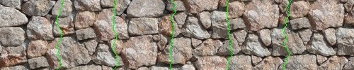

Image Quilting with seams